**DAILY ONLINE ACTIVITIES SUMMARY**

|  |  |  |  |  |  |  |  |  |
| --- | --- | --- | --- | --- | --- | --- | --- | --- |
| **Date:** | **09-06-2020** | | | | | **Name:** | **Apeksha Rane** | |
| **Sem & Sec** | **6th&A** | | | | | **USN:** | **4AL17CS010** | |
| **Online Test Summary** | | | | | | | | |
| **Subject** | | **Cryptography, Network Security and Cyber laws. (AND)**  **COMPUTER GRAPHICS AND VISUALIZATION** | | | | | | |
| **Max. Marks** | | **CNSC=60**  **CGV=30** | | **Score** | | | **CNSC=18**  **CGV=24** | |
| **Certification Course Summary** | | | | | | | | |
| **Course** | **INTRODUCTION TO FULL STACK DEVELOPMENT.** | | | | | | | |
| **Certificate Provider** | | | Greatlearning  Academy | | **Duration** | | | 14hours |
| **Coding Challenges** | | | | | | | | |
| **Problem Statement:**1. Write a C++ Program to rotate the matrix by K times.  2.  Write a Python to implement Perfect Sum Problem.  3. Write a Java Program to print smallest and biggest possible palindrome word in a given string.  4. Python Program to count even and odd numbers.  5. Write a Java Program to remove all white spaces from a string without using replace(). | | | | | | | | |
| **Status: Done** | | | | | | | | |
| **Uploaded the report in Github** | | | | | **YES** | | | |
| **If yes Repository name** | | | | | <https://github.com/Apeksha12appu/19-5-2020-online-coding-activity> | | | |
| **Uploaded the report in slack** | | | | | **YES** | | | |

Online Test Details:

Subject:- **Cryptography, Network Security and Cyber laws**

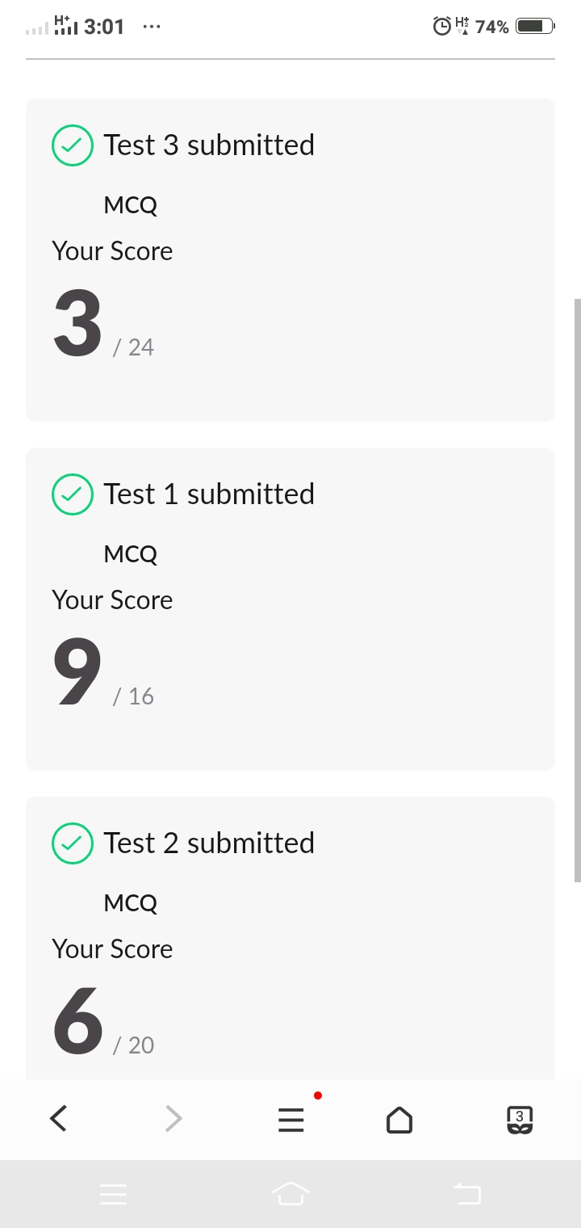

**COMPUTER GRAPHICS AND VISUALIZATION**

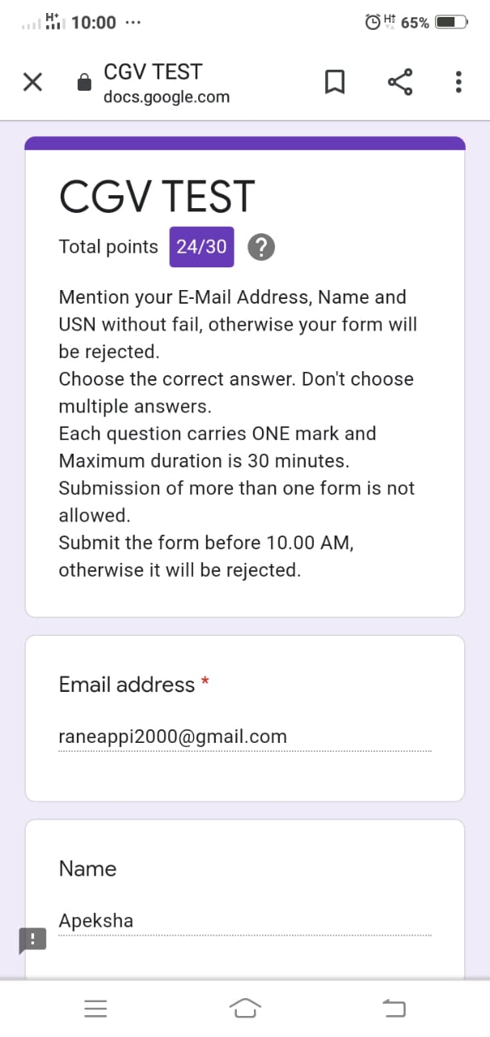

Certification Course Details:

**INTRODUCTION TO FULL STACK DEVELOPMENT.**

Today I have studied :

* Text Area.
* Text Area quiz.
* Drop Down and Value.
* Drop down and value attribute quiz.
* Radio button and checkboxes.
* Radio button and checkboxes quiz.
* Button Types.
* Button Types quiz.
* Div Tag.
* Div Tag assignment.

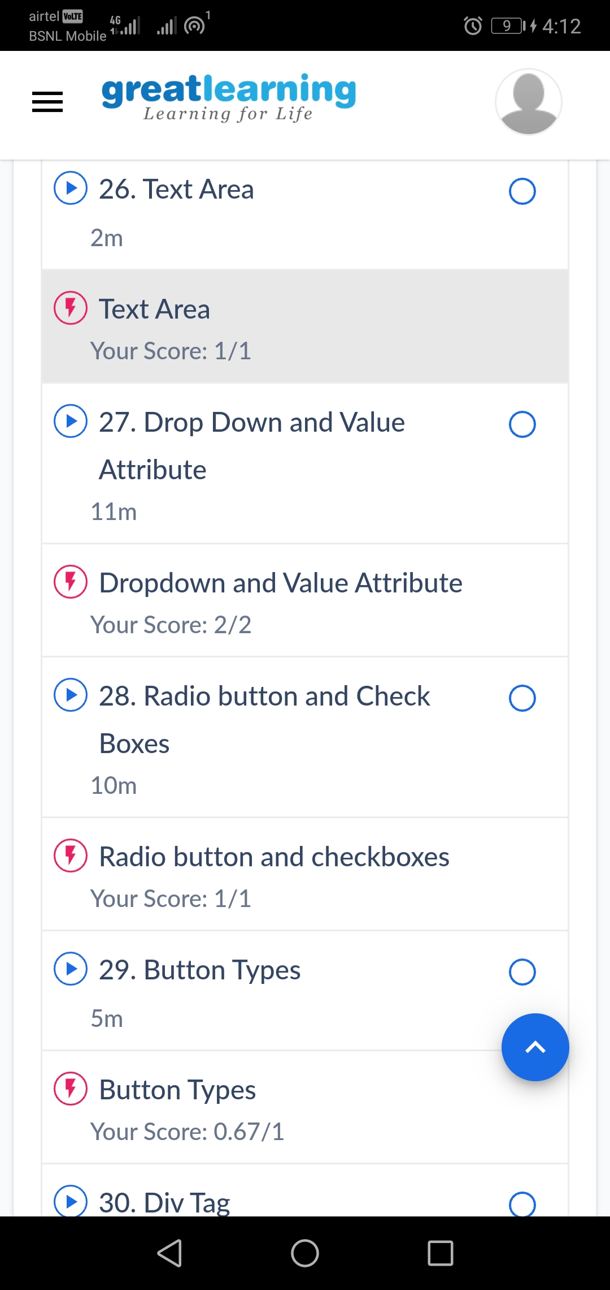

Coding Challenges Details:

1. Write a C++ Program to rotate the matrix by K times.

Rotate the matrix by K times means rotating the given NN matrix to the specified (K) number of times. For example, consider the 33 matrix, which has to be rotated once,  
Enter the Size of the Matrix: 3, 3  
Enter the Elements of the Matrix: 10, 20, 39, 40, 50, 60, 70, 80, 90  
Enter the value of K (Number of Rotations): 1  
Matrix before Rotation:  
10 20 30  
40 50 60  
70 80 90  
Matrix after Rotation:  
20 30 10  
50 60 40  
80 90 70

#include <iostream>

#define M 3

#define N 3

using namespace std;

void rotateMatrix(int matrix[][M], int k) {

int temp[M];

k = k % M;

for (int i = 0; i < N; i++) {

for (int t = 0; t < M - k; t++)

temp[t] = matrix[i][t];

for (int j = M - k; j < M; j++)

matrix[i][j - M + k] = matrix[i][j];

for (int j = k; j < M; j++)

matrix[i][j] = temp[j - k];

}

}

void displayMatrix(int matrix[][M]) {

for (int i = 0; i < N; i++) {

for (int j = 0; j < M; j++)

cout << matrix[i][j] << " ";

cout << endl;

}

}

int main() {

int matrix[N][M] = {{10, 20, 30},

{40, 50, 60},

{70, 80, 90}};

int k = 1;

rotateMatrix(matrix, k);

displayMatrix(matrix);

return 0;

}

**Output:**

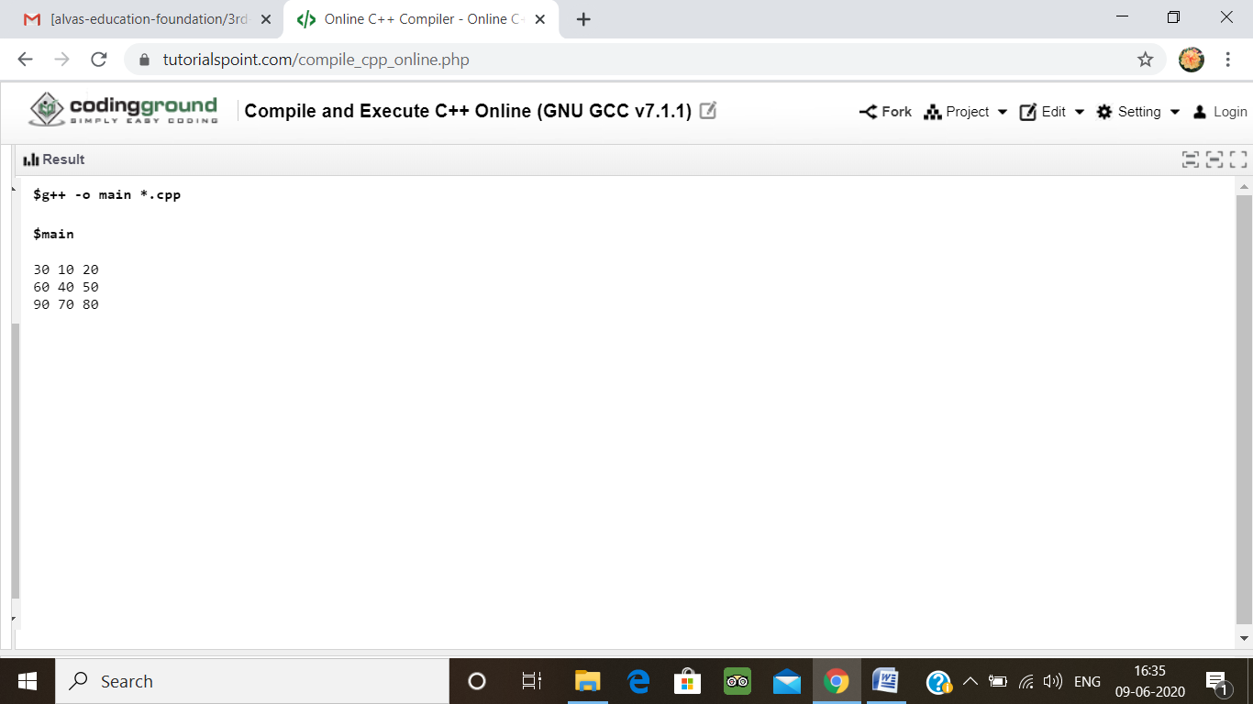

2. Write a Python to implement Perfect Sum Problem

Given an array arr[] of integers and an integer K, the task is to print all subsets of the given array with the sum equal to the given target K.

Input: arr[] = {5, 10, 12, 13, 15, 18}, K = 30

Output: {12, 18}, {5, 12, 13}, {5, 10, 15}

Explanation:  
Subsets with sum 30 are:  
12 + 18 = 30  
5 + 12 + 13 = 30  
5 + 10 + 15 = 30

def sumSubsets(sets, n, target) :

x = [0]*len(sets);

j = len(sets) - 1;

while (n > 0) :

x[j] = n % 2;

n = n // 2;

j -= 1;

sum = 0;

for i in range(len(sets)) :

if (x[i] == 1) :

sum += sets[i];

if (sum == target) :

print("{",end="");

for i in range(len(sets)) :

if (x[i] == 1) :

print(sets[i],end= ", ");

print("}, ",end="");

def findSubsets(arr, K) :

x = pow(2, len(arr));

for i in range(1, x) :

sumSubsets(arr, i, K);

if __name__ == "__main__" :

arr = [ 5, 10, 12, 13, 15, 18 ];

K = 30;

findSubsets(arr, K);

**output:**

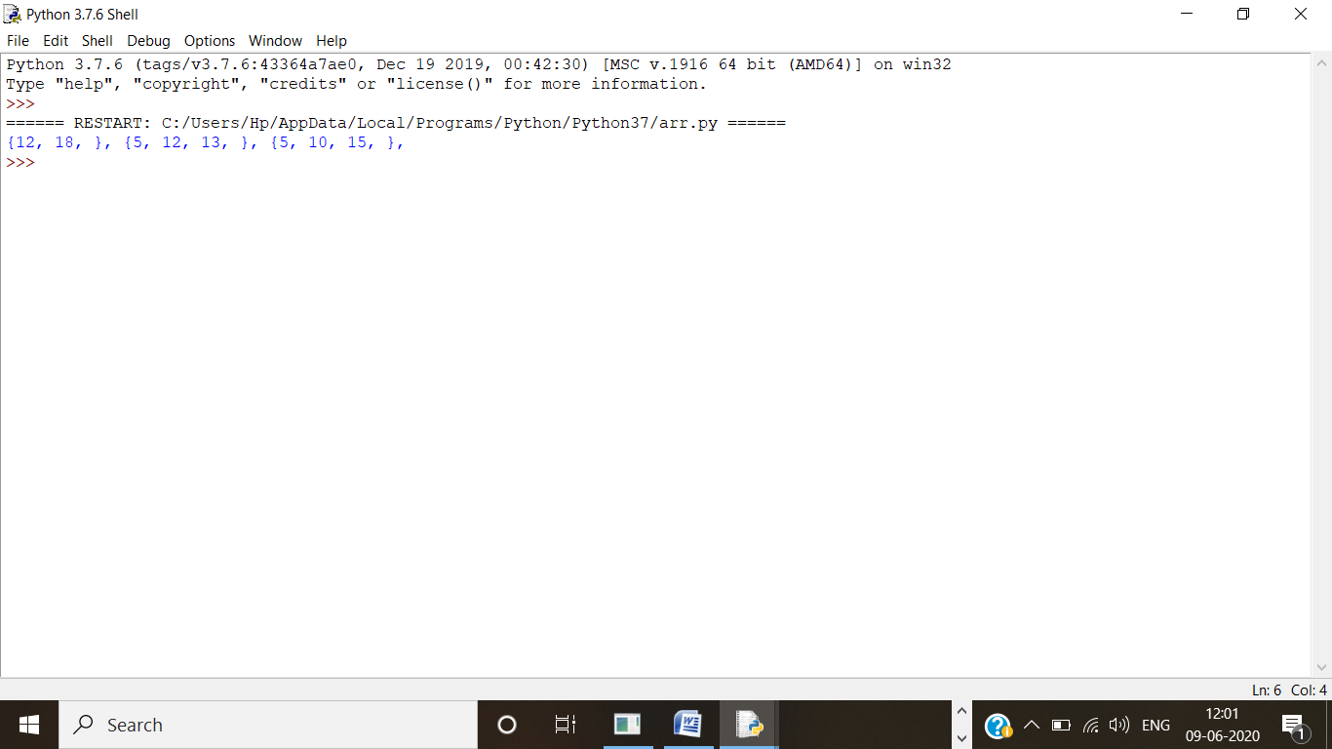

3. write a java Program to print smallest and biggest possible palindrome word in a given string

public class Main

{

    public static boolean isPalindrome(String a){

        boolean flag = true;

        for(int i = 0; i < a.length()/2; i++){

            if(a.charAt(i) != a.charAt(a.length()-i-1)){

                flag = false;

                break;

            }

        }

        return flag;

    }

    public static void main(String[] args){

        String string = "Wow you own kayak";

        String word = "", smallPalin = "", bigPalin="";

        String[] words = new String[100];

        int temp = 0, count = 0;

        string = string.toLowerCase();

        string = string + " ";

        for(int i = 0; i < string.length(); i++){

            if(string.charAt(i) != ' '){

                word = word + string.charAt(i);

            }

            else{

                words[temp] = word;

                temp++;

                word = "";

            }

        }

        for(int i = 0; i< temp; i++){

            if(isPalindrome(words[i])){

                count++;

                if(count == 1)

                    smallPalin = bigPalin = words[i];

                else{

                    if(smallPalin.length() > words[i].length())

                        smallPalin = words[i];

                    if(bigPalin.length() < words[i].length())

                        bigPalin = words[i];

                }

            }

        }

        if(count == 0)

            System.out.println("No palindrome is present in the given string");

        else{

            System.out.println("Smallest palindromic word: " + smallPalin);

            System.out.println("Biggest palindromic word: " + bigPalin);

        }

    }

}

Output:

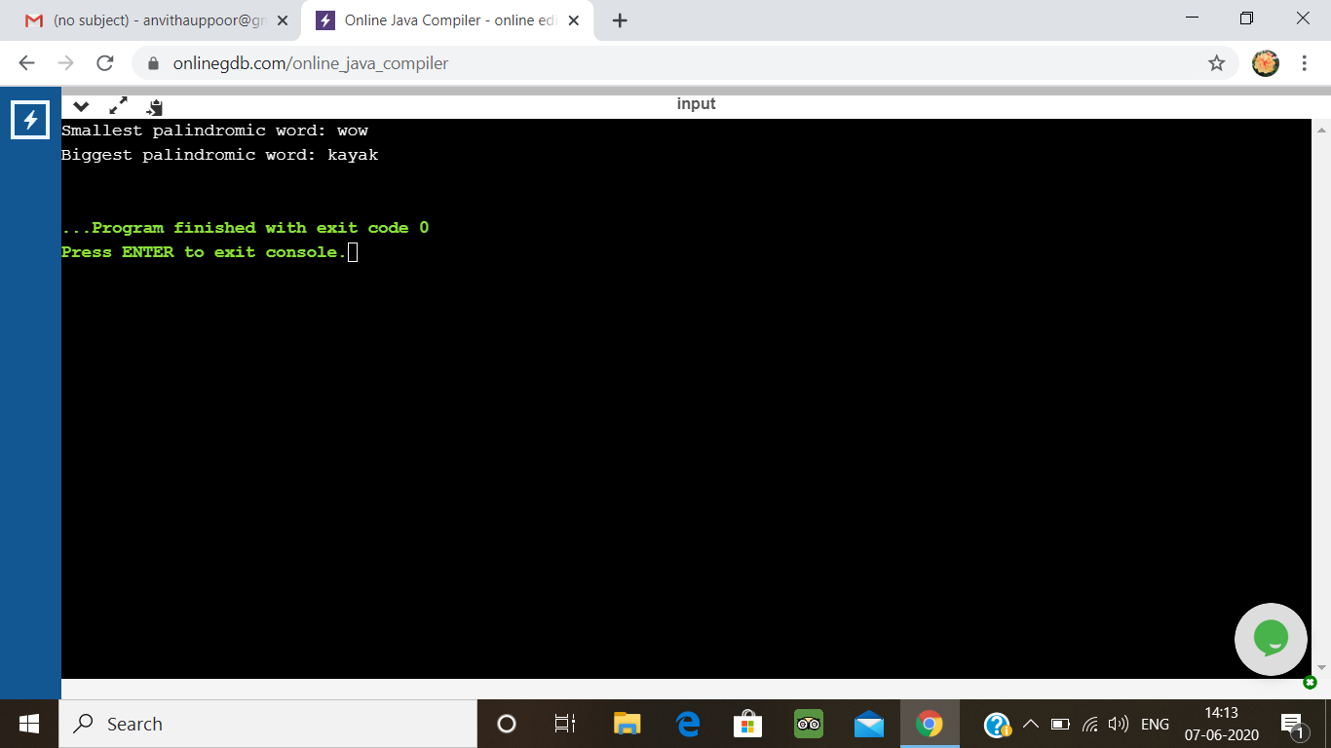

4. Python Program to count even and odd numbers

Write a Python program to count the number of even and odd numbers from a series of numbers.  
Numbers are = (1, 2, 3, 4, 5, 6, 7, 8, 9)  
Output:  
Number of even numbers : 5  
Number of odd numbers : 4

list1 = [1, 2, 3, 4, 5, 6, 7, 8, 9]

even_count, odd_count = 0, 0

for num in list1:

if num % 2 == 0:

even_count += 1

else:

odd_count += 1

print("Even numbers in the list: ", even_count)

print("Odd numbers in the list: ", odd_count)

**output:**

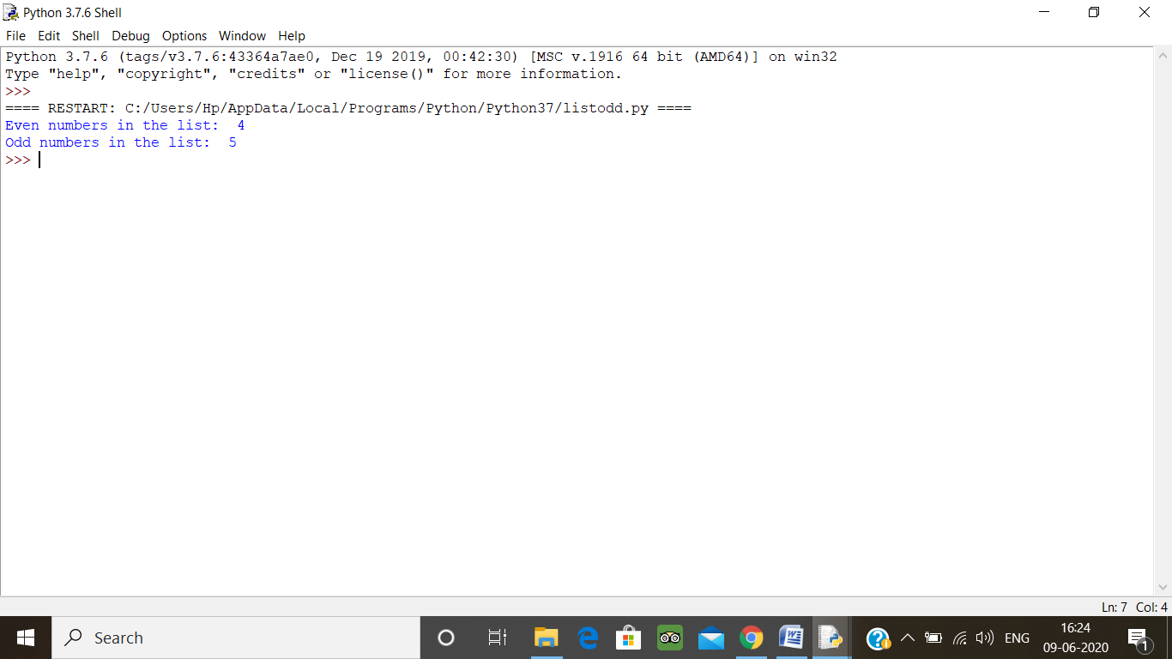

5. Write a Java Program to remove all white spaces from a string without using replace()

public class Main {

public static void main(String[] args) {

String str = "My Name is Anvitha ";

char[] strArray = str.toCharArray();

StringBuffer stringBuffer = new StringBuffer();

for (int i = 0; i < strArray.length; i++) {

if ((strArray[i] != ' ') && (strArray[i] != '\t')) {

stringBuffer.append(strArray[i]);

}

}

String noSpaceStr2 = stringBuffer.toString();

System.out.println(noSpaceStr2);

}

}

**Output:**

